

Program of Postgraduate Studies
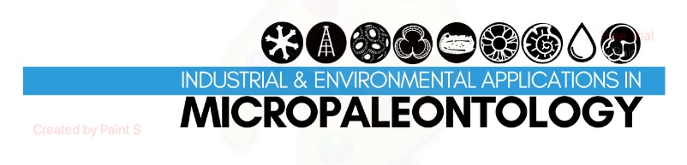

Given Name FAMILY NAME
Geologist/Biologist/….

PROVIDE HERE THE TITLE OF THE MASTER THESIS AS IT IS OFFICIALLY RECORDED
MASTER THESIS

Name of Student

Figure- optional

Athens, 202Χ

[blank page]

name FAMILY NAME

PROVIDE HERE THE TITLE OF THE MASTER THESIS

Submitted to the MSc course Industrial and Environmental Applications in Micropaleontology

Oral Examination Date: XX/XX/202Χ

Three-member Examining Board

Professor ………, Supervisor
Associate Professor ………, Member
Dr……, Member

© Name FAMILY NAME, 202X. Some rights reserved
Provide here the title of the master thesis – Master Thesis
The work is provided under the terms of Creative Commons CC BY-NC-SA 4.0.

Citation:
Family name X., 202X. – Provide here the title of the master thesis. Master Thesis, Program of Postgraduate Studies in Industrial and Environmental Applications in Micropaleontology. Department of Geology and Geoenvironment, National and Kapodistrian University of Athens, XX pp.

The views and conclusions contained in this document express the author and should not be interpreted as expressing the official positions of the National and Kapodistrian University of Athens.

Cover Figure: (cite if necessary)

ABSTRACT

TABLE OF CONTENT

TABLE OF FIGURES

